# KIPU Health Capacity Deployment

# Work Order Number - 3

This KIPU Health Work Order ("Work Order") shall be governed by the terms and conditions of the Independent Contractor Agreement by and between **KIPU Health ("CLIENT")** and **Veersa ("CONTRACTOR")** effective on **April 26th, 2020 (the "Effective Date")**. In the event of a conflict between the terms of this Work Order and the Agreement or any Purchase Order, the terms of this Work Order shall prevail.

Capitalized terms used but not defined in this Work Order have the meanings ascribed to such terms in the Agreement.

The following sets forth the terms and conditions under which CONTRACTOR shall provide consulting services as requested by CLIENT (the "SERVICES").

1. CONTRACTOR will provide capacity to assist KIPU Health in various technology initiatives. Currently a total of **608 (Six Hundred Eight) Person Months of capacity** to execute the projects specified in **Exhibit A**: RCM Module Development and **Exhibit B**: Enterprise PMO Oversight, **Exhibit C**: QA Automation

Following Table provides the break-up of the effort per months:



The Contractor will provide the capacity for the following roles:



1. **Specific utilization** of resources will be governed by Project exhibits that define scope, utilization and billing schedule for duration of each project.
2. **Management / Governance of Capacity Model**: Program Steering Committee comprised of KIPU and Veersa Leadership will define/review utilization projection along with corresponding monthly billing for a minimum of each quarter, linked to specific work components/sprints. Utilization projection could be for longer duration if the sprint(s) is/are longer. Veersa will update and release capacity utilization dashboard once a month, at the beginning of the month that covers (a) capacity utilized till date linked to specific projects / sprints (b) projection of utilization linked to specific projects/sprints (c) capacity availability for the remainder tenure of this SOW (d) Billing till date as well as billing projection by month for remainder of SOW duration linked to specific projects / sprints.
3. **Change management**: Any change in scope, complexity, acceleration of timelines in any of the project exhibits resulting in impact on resource capacity and corresponding billing schedule will be governed by a change request addendum, approved via email by Kipu. Such changes will get added to the overall capacity model and its governance schedule
4. **Billing:** Once a project exhibit and its billing schedule has been approved, Veersa will pre-bill for each month's projected utilization at the beginning of such month, with payment due upon invoice receipt. Any required adjustments will be made in the subsequent month’s invoice.
5. **Invoices and Payments**: Invoices will be sent via email to: Todd Lee; [todd@kipu.health](mailto:todd@kipu.health).
   1. Payment of all invoices are due on receipt.
   2. CLIENT will make payments via bank wire transfer to the bank account as mentioned in each submitted invoice.
   3. CLIENT will reimburse CONTRACTOR for any pre-approved travel and out-of-pocket expenses incurred in connection with the provision of the Services subject to actuals.
   4. CONTRACTOR shall affix the approval to all invoices where it is seeking reimbursement for expenses.
   5. Invoices for travel and out-of-pocket expenses incurred shall include:
      1. A complete and accurate expense log for the relevant period.
      2. Scanned receipts for all expenses.
6. **Termination**: As per “Executed KIPU MSA” Clause 11.2
7. Details of current projects are provided in the following Exhibit A, B and C.

The terms and conditions of this Agreement are agreed to by:

CLIENT CONTRACTOR

_______________________________ _______________________________

Signature Signature

_______________________________j _______________________________

Date Date

_______________________________ _______________________________

Name Name

_______________________________ _______________________________

Title Title

**Exhibit A: RCM Development Project**

1. RESOURCES PROVIDED BY CONTRACTOR SHALL CONFORM TO THE FOLLOWING:
   1. CONTRACTOR shall perform the Services described as the following:

Establish a delivery team which will develop the RCM Module with overall functional and technical scope as provided in Appendix A – Scope of RCM module

* 1. The following activities will be performed as part of this project:

|  |  |
| --- | --- |
| Scope of tasks | Total Amount |
| 1. Work with KIPU Product Manager to create a backlog, prepare an overall product development plan and then plan for sprints to meet the overall product development plan. 2. Create detailed user stories to elaborate the desired functionality for each feature identified in the functional and technical scope. 3. Create UI and UX design for user stories. 4. Elaborate the technical architecture components and solution design. 5. Develop the code to implement the user stories. 6. Conduct functional and regression testing of developed features. 7. Deploy and release completed units to QA and Production environments 8. Help in the setup of the different environment and with the release process. 9. Regularly communicate and present project status as per communication plan. | As per each month. Rate card in Appendix C: Rate Card & Monthly Burn Chart |
| Out of scope –   * Any activity not explicitly mentioned in Scope of Tasks, unless mutually agreed between CLIENT and CONTRACTOR. * CLIENT product setup deployment. | |
| Deliverables: As per delivery plan – Appendix B: Delivery Plan | |

1. Services shall be delivered at the following location:
   1. Remotely, or at CONTRACTOR’s offices anywhere in the world. CONTRACTOR’s resources will follow local holidays calendar and office timings.
2. ASSUMPTIONS
3. The current effort estimates are basis the high-level requirements captured by Veersa team and assuming low to medium level of complexity on an average. During the detailing of the requirements if there is a change of scope in terms of acceleration of timelines, material increase in the number and complexity of each story, then a revised effort estimate will be submitted and provided as change request to CLIENT. Any augmentation of the timelines or team members will be made post the approval.
4. The technical architecture is based on certain assumptions on the feasibility of third-party components. These will be validated for applicability during the initial few sprints of the delivery phase. Any change in complexity of the architecture due to changes in the underlying 3rd-party components will need to be re-estimated and raised as change request for client’s approval
5. Any delays in implementation of changes required in the EMR product, resulting in extension in timelines for the RCM billing module will need to be re-estimated and revised as change request.
6. INVOICES and PAYMENT

As per the Point 6 in the main document above.

1. TERM

The project shall commence on June 7, 2021 and end on Dec 31, 2022, extendable by mutual consent of CLIENT and Veersa by email / written confirmation.

# Appendix A: Scope of the RCM Application

1. Functional Scope

|  |  |  |  |
| --- | --- | --- | --- |
| **ID** | **Scrum Name** | **Scrum Scope** | **Story Points** |
| 0 | Environment setup and Architecture | Setup and validate working overall architecture skeleton with Integration suite, Identify access management, messaging bus. Setup DevOps environment with code repository, continuous build and deploy on different environments – development, QA, UAT etc. Develop the overall UI/UX theme for the product, to be further detailed for each user story. | 286 |
| 1 | Common Components | Build common standard and components that can be used across product screens and Applications – table, grids, menu, alerts, documents, notes etc. | 226 |
| 2 | Configuration and Entities Setup | Setting up Payer, Facilities, Practices, etc. Setting up codes CPT, HCPCS, ICD, Revenue, remittance, adjustments, revenue etc. Contract Management, fee schedule, patient statement configurations, account administration, user roles management, clearing house setup etc. | 735 |
| 3 | Scheduler | Manage Appointment types and statuses, view Eligibility, Print Schedules, Manage Waiting List, Appointment Control, Manage Appointments, Create/Edit/Delete Appointment Blocks, Create an Appointment, Appointment Reminders etc. | 347 |
| 4 | Pre-Admission and Admission | Authorization, Patient Check-in, Manage Patient Account, Ability to run eligibility check individually or in batch, Batch Eligibility, Patient Copayment & deductible collection, Patient Payment Arrangements, Eligibility Check. | 187 |
| 5 | Claims Processing | Find, edit, update claim, update claim status, managing Incomplete claim, delete a claim, print options, transaction History, review a claim, view claim Activity, View Claim Summary, Manage Patient Claim Notes, Manage Follow Up Activity, Manage Documents for a claim, re-submit a claim, ability to filter and review existing claims, ability to create and edit new claim, ability to do claims follow-ups etc. | 761 |
| 6 | Payment and Accounting | Post Payments, General Ledger, Patient Portal Features, Payment Actions, Managing ERA, A/R Management, Send Notifications, Statement Batch Print, Manage Payment Plans, Payment Tracker, Generate Patient Statements, Applying Credit, View Payment, Manage Write-offs, Manage Collections, | 644 |
| 7 | Reporting | Customer Analytics Dashboard, Report Viewer, Report Builder etc. | 198 |

1. Technical Scope

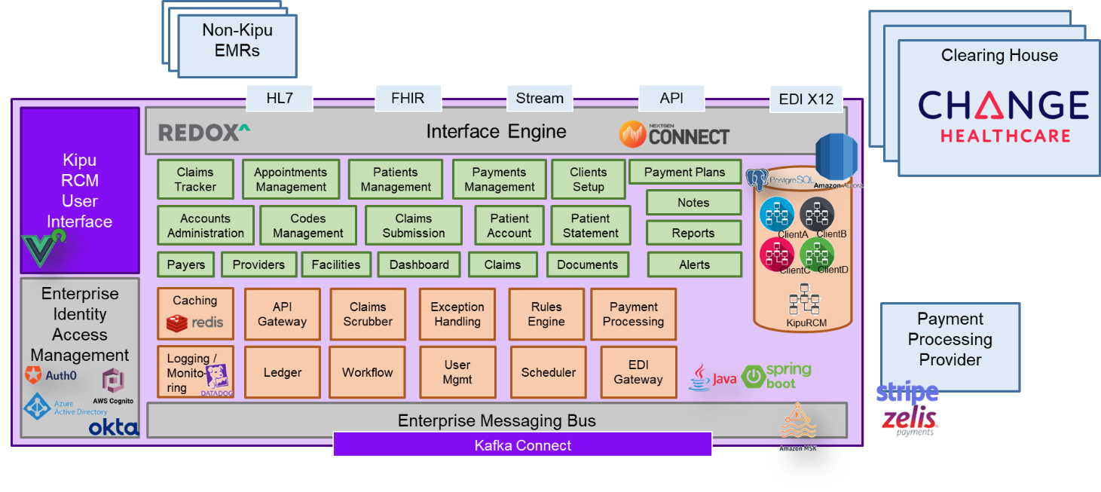

# Appendix B: Tentative Delivery Plan

# 

During the execution phase of the project, plan will be further discussed and agreed between CLIENT and CONTRACTOR.

# 

# Appendix C: Rate Card & Monthly Burn Chart

# 

# Note: *Total Monthly cost has been calculated basis # of working days in that month and the team daily rate*

**Exhibit B: Enterprise PMO**

1. RESOURCES PROVIDED BY CONTRACTOR SHALL CONFORM TO THE FOLLOWING:
   1. CONTRACTOR shall perform the Services described as the following:

Provide a Senior Enterprise Program Manager, who will help KIPU executive leadership team in program governance of strategic technology initiatives and the global delivery model.

* 1. The following are broad functions to be performed by the Enterprise Program Manager

|  |  |
| --- | --- |
| Scope of tasks | Total Amount (per month) |
| 1. Provide updates on technology initiatives on a monthly basis:    1. Status of projects    2. Utilization Trend    3. Monthly Burn Rate Update    4. Milestones Achievements    5. Risks and Issues 2. Coordinate and manage resource allocation and utilization across technology programs 3. Help in resource planning and strategic product roadmap formulation | As per payment schedule in **Appendix A: Payment Schedule Enterprise PMO**  Expected utilization: 35% in month |
| Out of scope –   * Any activity not explicitly mentioned in Scope of Tasks, unless mutually agreed between CLIENT and CONTRACTOR. * CLIENT product setup deployment. | |
| Deliverables: Monthly Program Dashboard | |

1. Services shall be delivered at the following location:
   1. Remotely, or at CONTRACTOR’s offices anywhere in the world. CONTRACTOR’s resources will follow local holidays calendar and office timings.
2. INVOICES and PAYMENTS

As per Point 6 of the main section.

1. TERM
   1. Term runs through 12/31/22; however, Kipu Health and Veersa can enter into good faith negotiations on a 90 day wind down or resource reassignment starting January 1, 2022.

**APPENDIX A: Payment Schedule Enterprise PMO**



**Exhibit C: QA Automation Support**

1. RESOURCES PROVIDED BY CONTRACTOR SHALL CONFORM TO THE FOLLOWING:
2. CONTRACTOR shall perform the Services described as the following:
   * 1. Provide a team of QA Automation Lead and Engineers to help KIPU QA team establish an automation framework and create automation scripts for existing test cases to test the KIPU product suite.
     2. Following table defines the broad task of the project:

|  |  |
| --- | --- |
| Scope of Tasks | Total Amount |
| 1. Perform an Assement of current state of QA automation in KIPU, understand application scope, existing test cases and finalize approach for automation 2. Customize Veersa Automation Framework to create KIPU automation framework 3. Create the automation plan and automation scripts 4. Run automation scripts | **As per Appendix A: Payment Schedule QA Automationn** |
| Out of scope –   * Any activity not explicitly mentioned in Scope of Tasks, unless mutually agreed between CLIENT and CONTRACTOR. * CLIENT product setup deployment. | |
| Deliverables:   1. Automation Framework 2. Automation Scripts | |

1. Services shall be delivered at the following location:
2. Remotely, or at CONTRACTOR’s offices anywhere in the world. CONTRACTOR’s resources will follow local holidays calendar and office timings.
3. KIPU Health will reimburse Contractor for any preapproved travel and out-of-pocket expenses incurred in connection with the provision of the Services subject to actuals
4. Contractor shall affix the approval to all invoices where it is seeking reimbursement for expenses.
5. INVOICING AND PAYMENT

As per Point 6 of the main section of this document**.**

1. TERM
   1. Term runs through 12/31/22; however, Kipu Health and Veersa can enter into good faith negotiations on a 90-day wind down or resource reassignment starting January 1, 2022.

# Appendix A: Payment Schedule QA Automation

|  |  |  |  |
| --- | --- | --- | --- |
| **S.No.** | **Role** | **Rate (USD Per Hour)** | **Daily Rate** |
| **1** | **QA Lead** | **$35** | **$280** |
| **2** | **QA Automation Engineer** | **$30** | **$240** |

# 